|  |
| --- |
| **LAPORAN PRAKTIKUM JARINGAN KOMPUTER**  **2.9.1**  **PACKET TRACER – BASIC SWITCH AND END DEVICE CONFIGURATION** |
|  |
| **Agus Pranata Marpaung**  **13323033**  **DIII TEKNOLOGI KOMPUTER** |
| **INSTITUT TEKNOLOGI DEL**  **FAKULTAS VOKASI** |

**Judul Praktikum**

|  |  |  |
| --- | --- | --- |
| **Minggu/Sesi** | : | I/3 |
| **Kode Mata Kuliah** | : | 1032101 |
| **Nama Mata Kuliah** | : | JARINGAN KOMPUTER |
| **Setoran** | : | Jawaban dalam bentuk *softcopy* |
| **Batas Waktu Setoran** | : | *Sesi Praktikum Selanjutnya* |
| **Tujuan** | : | 1. Mahasiswa dapat mengidentifikasi komponen pada jaringan komputer dan juga dapat melakukan konfigurasi sederhana terhadap switch dan end device dengan menggunakan simulator Packet Tracer. |

**Petunjuk**



**Packet Tracer - Basic Switch and End Device Configuration**

# Addressing Table

|  |  |  |  |
| --- | --- | --- | --- |
| **Device** | **Interface** | **IP Address** | **Subnet Mask** |
|  | VLAN 1 |  | 255.255.255.0 |
|  | VLAN 1 |  | 255.255.255.0 |
|  | NIC |  | 255.255.255.0 |
|  | NIC |  | 255.255.255.0 |

**Answer:**

|  |  |  |  |
| --- | --- | --- | --- |
| **Device** | **Interface** | **IP Address** | **Subnet Mask** |
| Class-A | VLAN 1 | 128.107.20.10 | 255.255.255.0 |
| Class-B | VLAN 1 | 128.107.20.15 | 255.255.255.0 |
| Student-1 | NIC | 128.107.20.25 | 255.255.255.0 |
| Student-2 | NIC | 128.107.20.30 | 255.255.255.0 |

# Objectives

* Configure hostnames and IP addresses on two Cisco Internetwork Operating System (IOS) switches using the command-line interface (CLI).
* Use Cisco IOS commands to specify or limit access to the device configurations.
* Use IOS commands to save the running configuration.
* Configure two host devices with IP addresses.
* Verify connectivity between the two PC end devices.

# Scenario

As a recently hired LAN technician, your network manager has asked you to demonstrate your ability to configure a small LAN. Your tasks include configuring initial settings on two switches using the Cisco IOS and configuring IP address parameters on host devices to provide end-to-end connectivity. You are to use two switches and two hosts/PCs on a cabled and powered network.

**Instructions**

Configure the devices to fulfill the requirements below.

# Requirements

* Use a console connection to access each switch.
* Name **Class-A** and **Class-B** switches.
* Use the **R4Xe3** password for all lines
* Use the **C4aJa** secret password.
* Encrypt all clear text passwords.
* Configure an appropriate message-of-the-day (MOTD) banner.
* Configure addressing for all devices according to the Addressing Table.
* Save your configurations.
* Verify connectivity between all devices.

**Answer:**

*Before starting, we will fill in the IP Address on each Student PC, namely Student-1 PC and Student-2 PC.*

* Student-1 PC

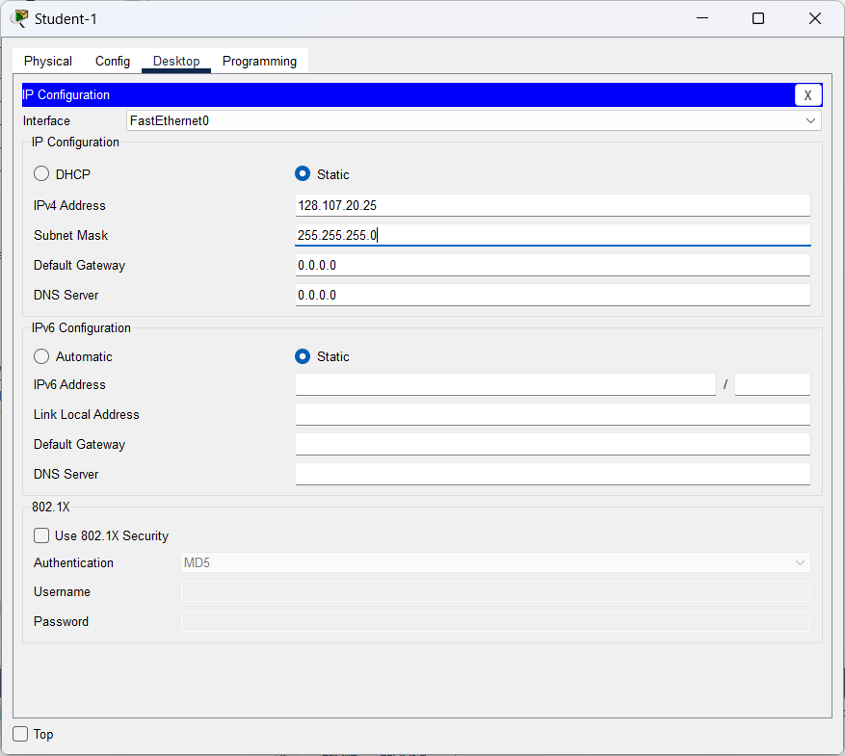

* Student-2 PC

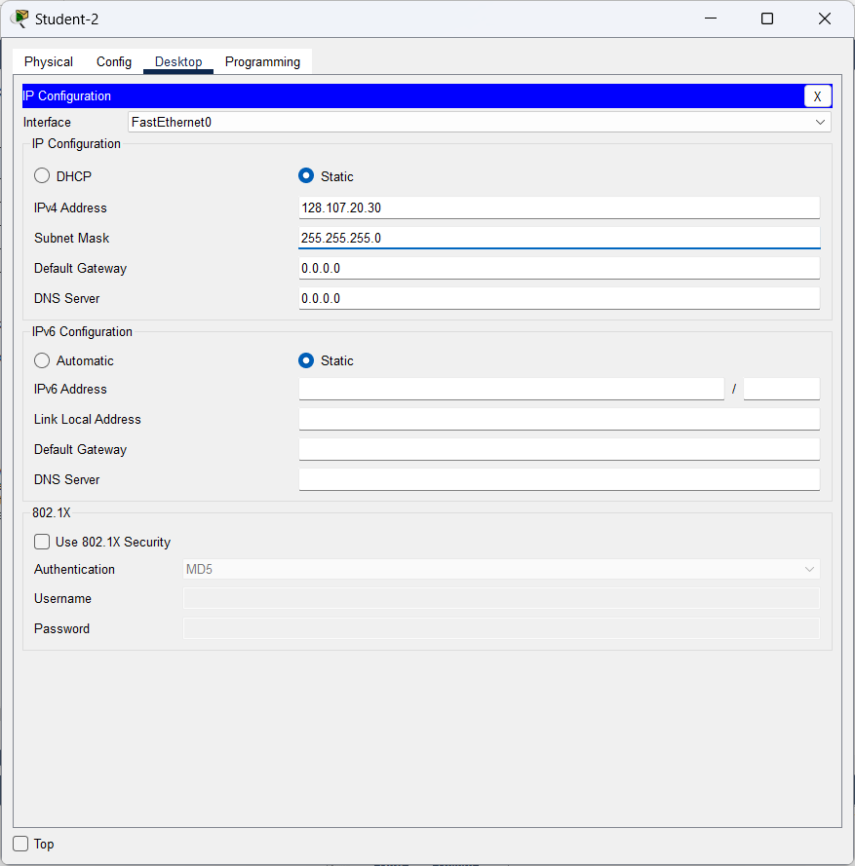

**Steps:**

* First, we connect the PC to the switch by using Console on Connection by using RS 232 for Students-2 PC to Console for Class-B Switch.

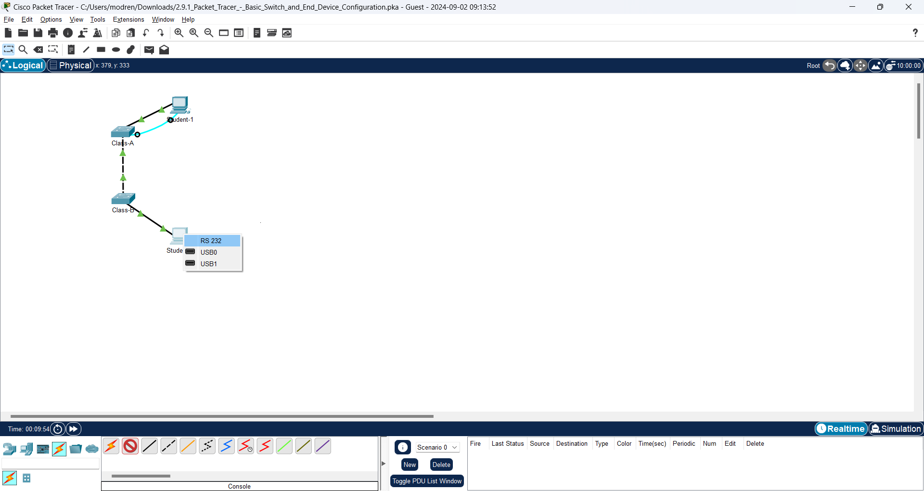

* And likewise with Student-1 PC to Switch Class-A.

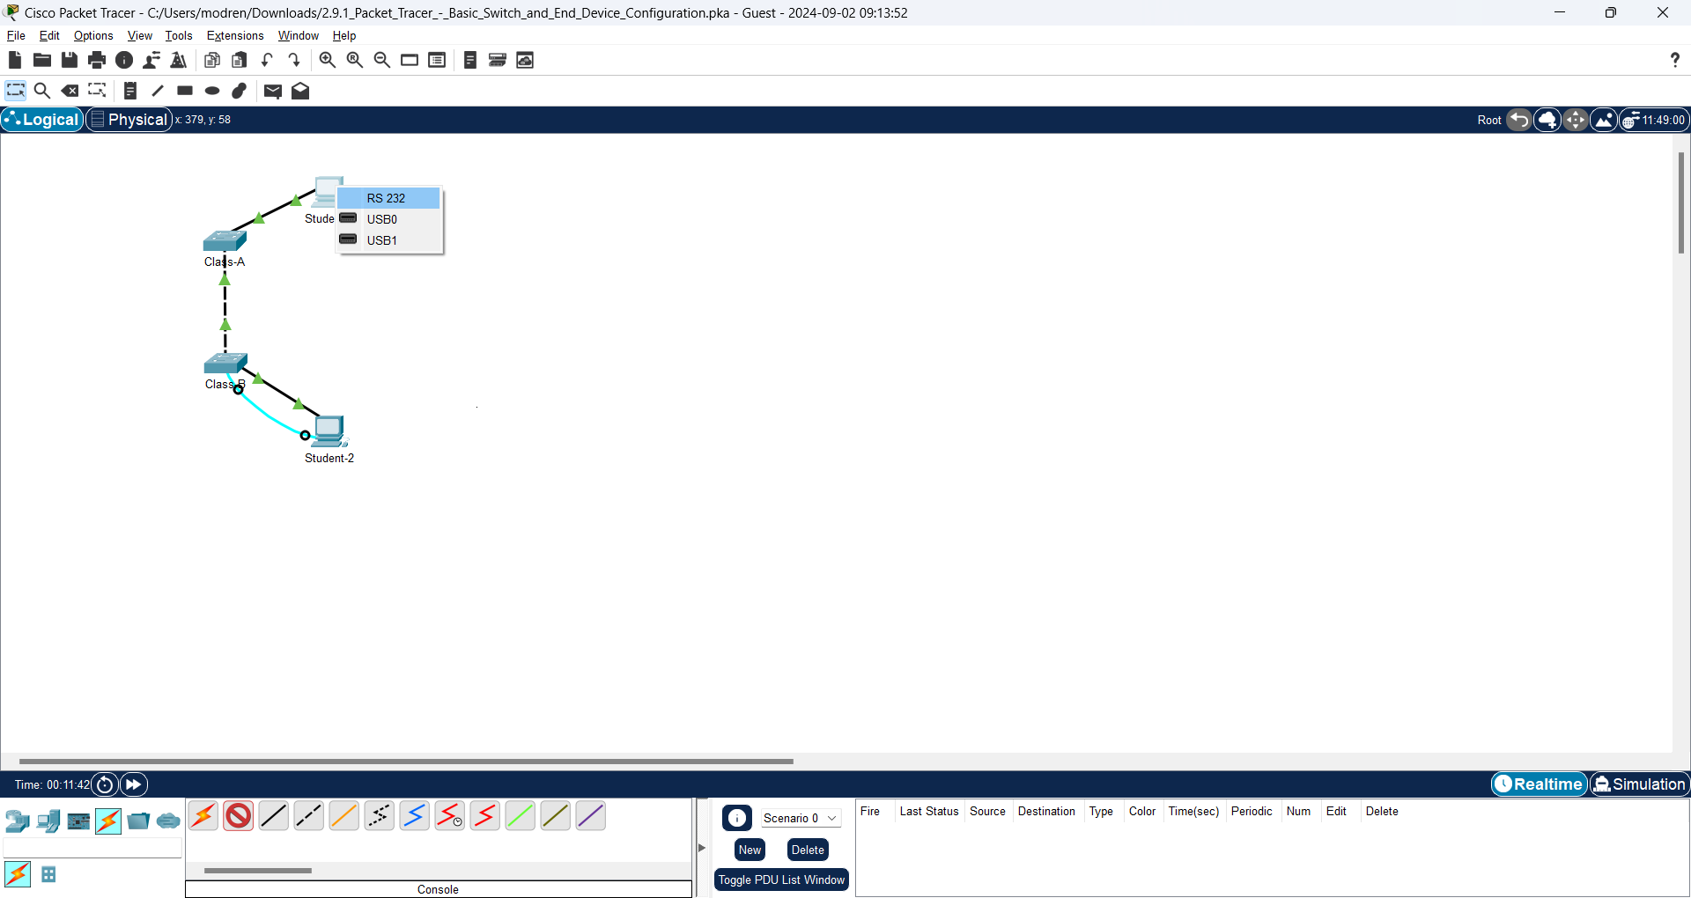

* Then, we will do it on PC Student-1 and will connect to Switch Class-A and we will create the secret password. Here's the command:

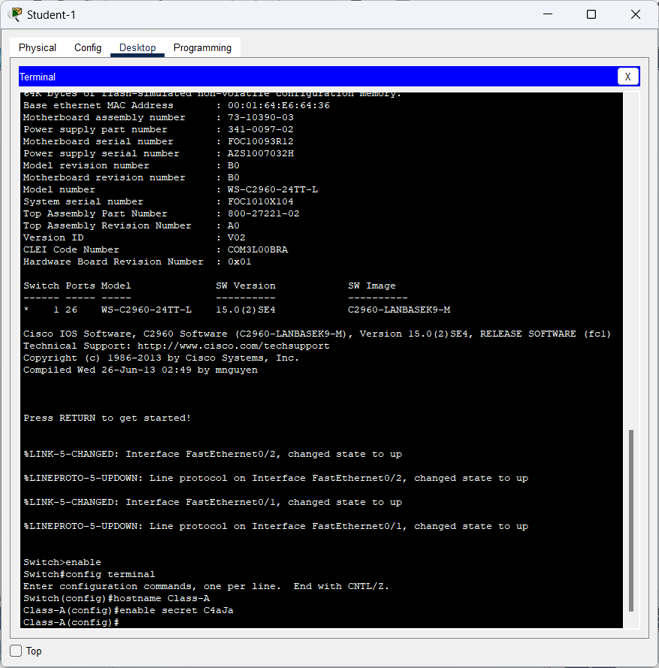

* And then, we will connect to line console and create the Password for All lines.

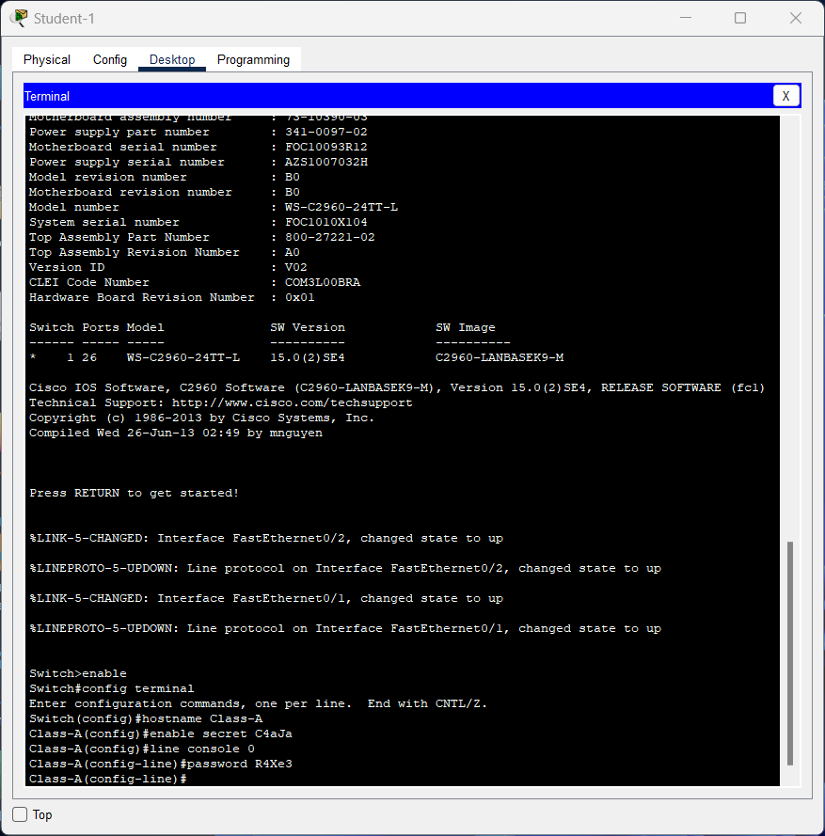

* And then, we will connect to Switch Class-A using Password and then Exit.

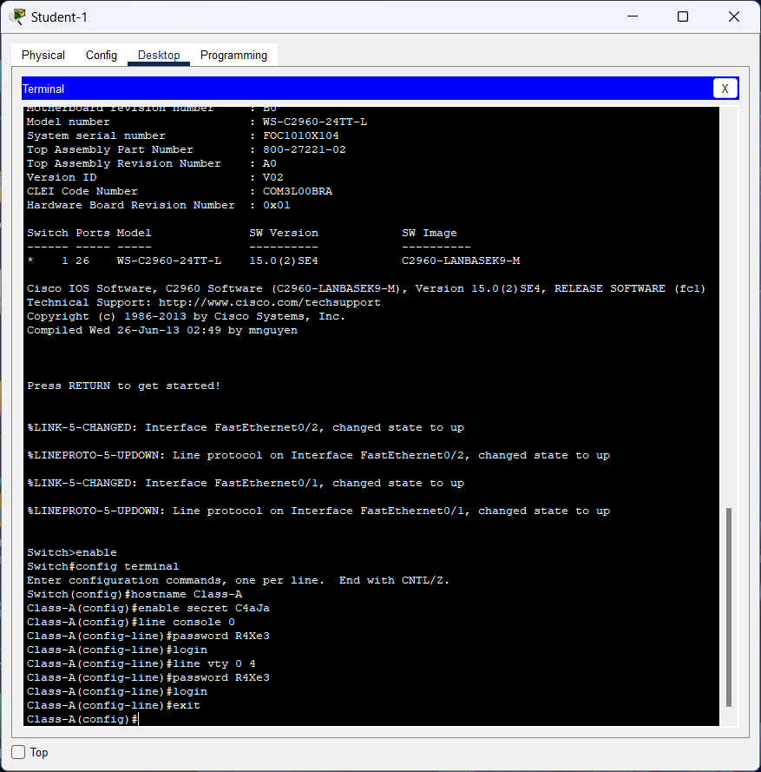

* And then, we will encrypt all password on the Switch and Config a banner and access to the IP Address and Subnet Mask.

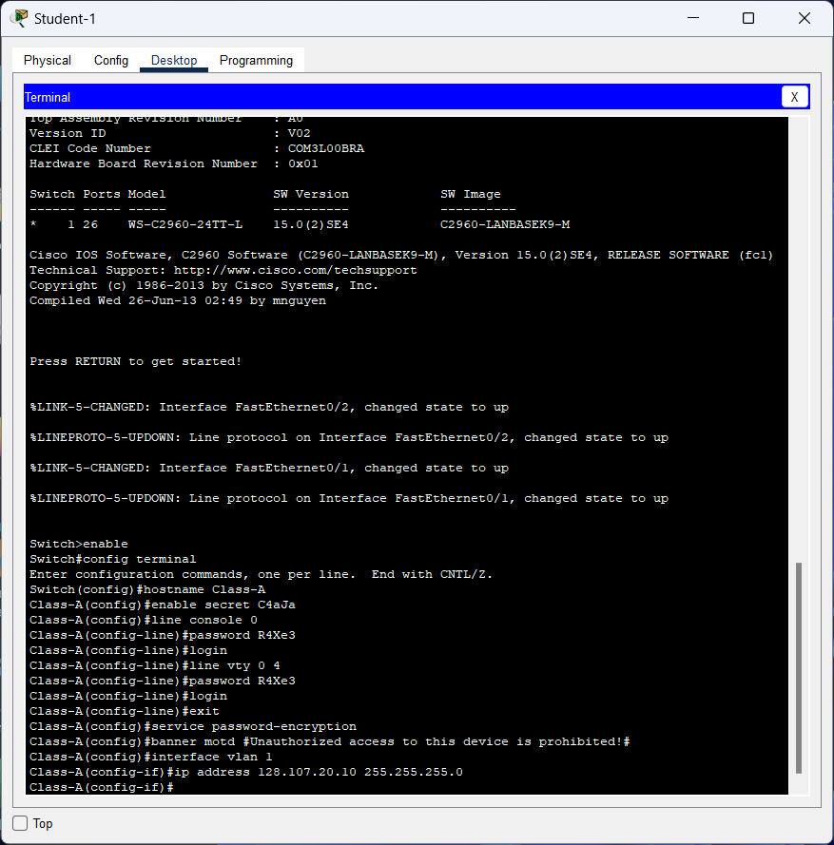

* And then we will end the terminal and copy running-config to startup-config

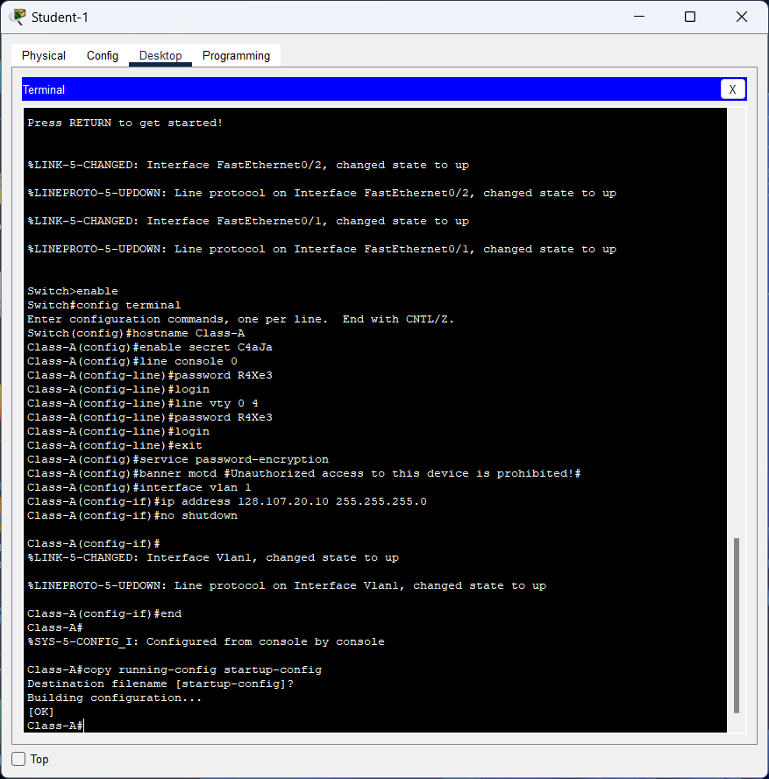

* Then, we will do it on the Student-2 PC and will connect to the Class-B Switch. Here's the command to get started:

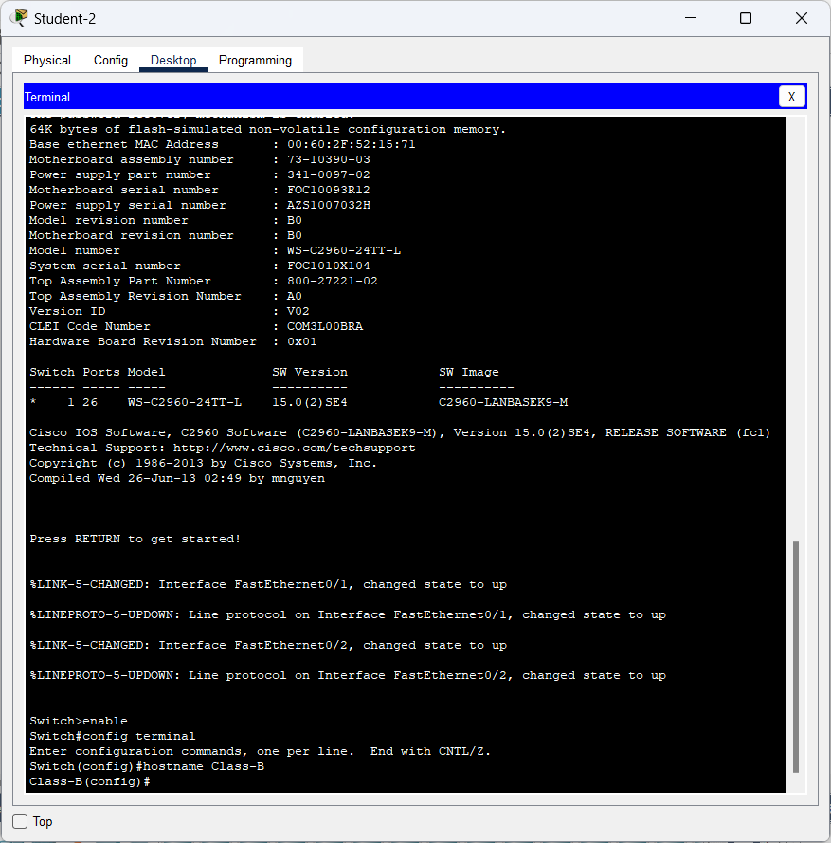

* And then, we'll create a secret password and connect to the line console.

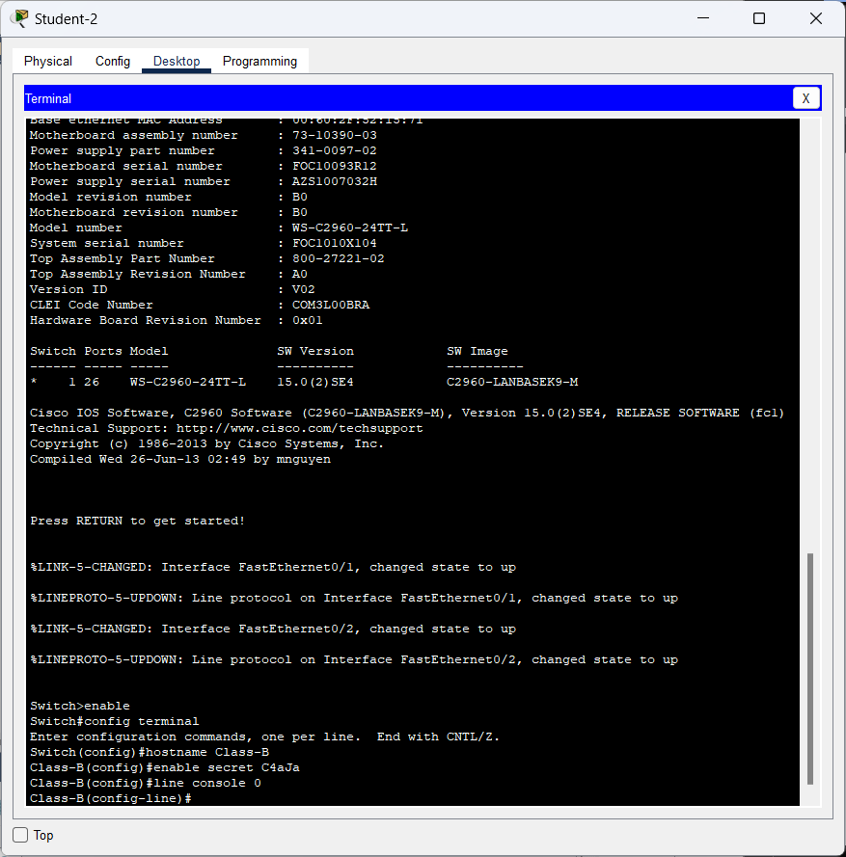

* After that, we will create a password for all lines then login and enter the previously created password on the all lines password.

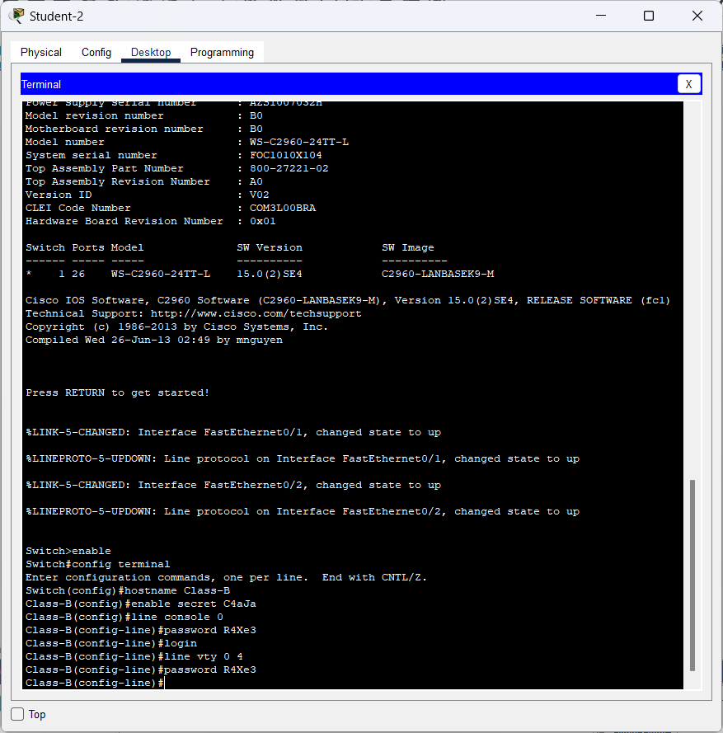

* Then, exit and perform password encryption and configure a banner on the command.

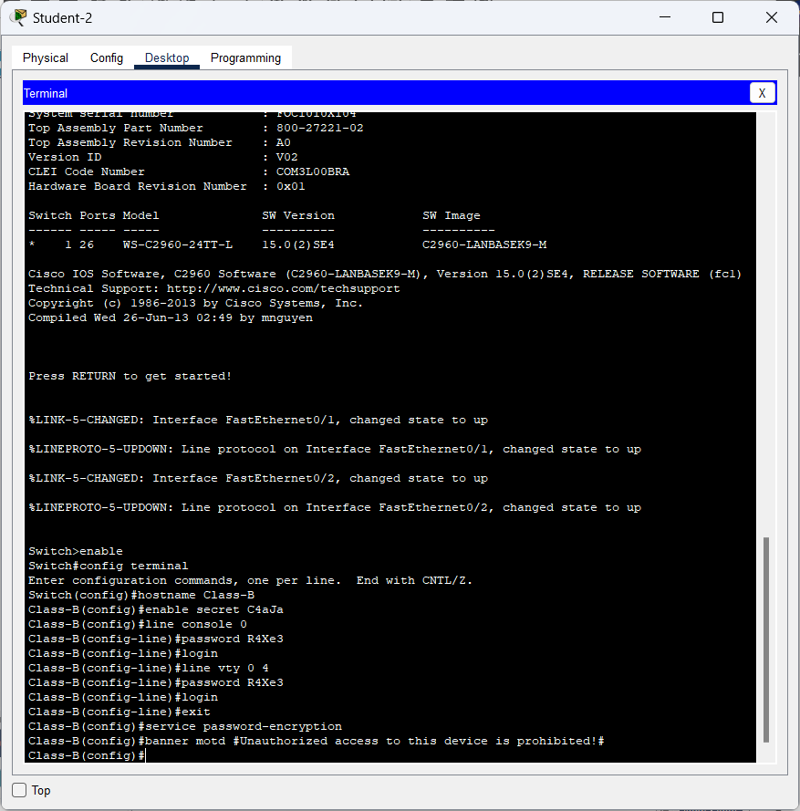

* After we configure the banner, we will run the interface on vlan 1 and do so for the IP Address with Subnet Mask on the Class-B Switch and end the command and make a copy of the running-config in startup-config, then press enter.

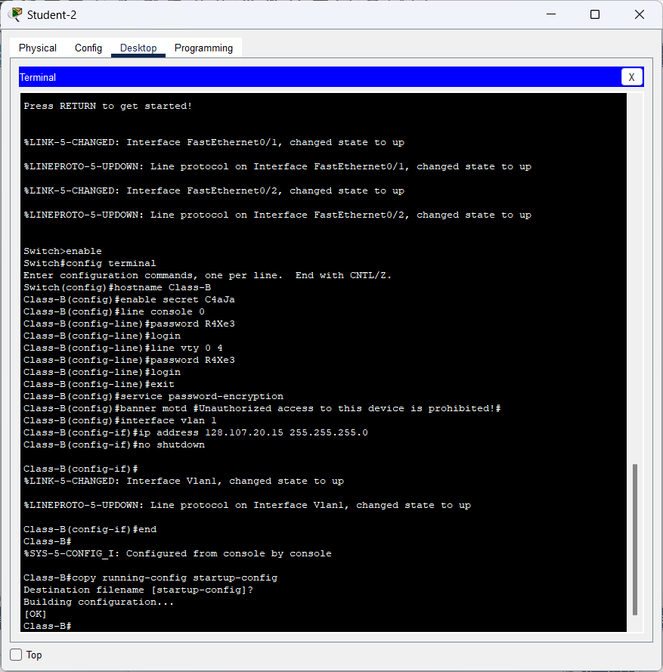

**Note:** Click **Check Results** to see your progress. Click **Reset Activity** to generate a new set of requirements. If you click on this before you complete the activity, all configurations will be lost.